Nepal College of Information Technology
Assessment
Fall 2010
Program: IT Time: 3 hrs
Semester: Fall (V) FM: 100
Subject: Principles of Communication PM: 50

The figures in the margin indicate full marks.
Attempt all the questions:
1. | - Draw a generic block diagram of a digital communication system and explain the basic signal processing operations at the transmitter and receiver.  - Define deterministic and random waveforms. An analog signal is band limited to B Hz, sampled at 10% more than the Nyquist rate and sampled at 8 levels. The quantization levels Q1, Q2, Q3, Q4, Q5, Q6, Q7 and Q8 are assumed independent and occur with probability p1 = ½, p2 =p8 =1/8, p3=p5=p7=1/16 and p4=p6=1/32. Find the information rate. | 7  2+6
2. | - Explain power spectral density and auto-correlation function of a signal. Find the Fourier Series of a signal given below.  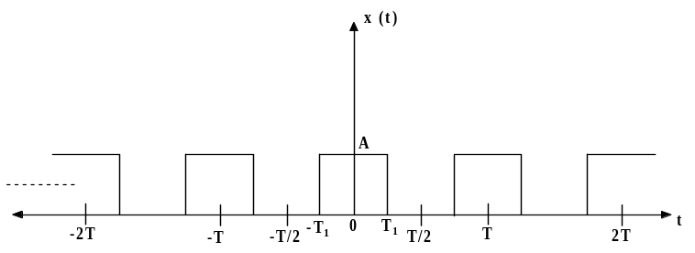  b) Explain the difference between PAM, PWM and PPM. How is pulse-time modulated signal generated from an analog waveform? Explain with the help of necessary diagrams. | 8  7
3. | - Differentiate between DPCM and DM. Explain granular noise and slope overload distortion in delta modulation.  - A television signal has a band width of 30.5 MHz This signal is sampled, quantized and binary coded to obtain PCM signal.  - Determine the sampling rate, if the signal is to be sampled at a rate 20% above Nyquist rate.  - If the samples are quantized in to 1000 levels, determine no. of binary pulses required to encode each sample.  - Determine the binary pulse rate (bps) of the binary coded signal and the minimum bandwidth required to transmit the encoded signal.(Assume Noiseless system) | 8  7
4. | - Draw and explain the super heterodyne receiver for AM radio.  - What is the function of detector circuit? Explain any one method of AM detection. | 7  8
5. | - Define Amplitude Modulaion in brief. Show that total power in the sidebands of AM wave is only one third of the total power of the modulated wave and also find the maximum efficiency at μ=1.  - Calculate the percentage power saving when the carrier and one of the side bands are suppressed in an DSB-AM wave modulated to a depth of  - 100% ii.53% iii. 83% | 8  7
6. | - Define digital modulation techniques in brief. Explain QPSK modulation technique with the help of clean diagram | 8
 | - What is frequency division multiplexing (FDM) technique? Explain in detail. How does it differ from TDM? | 7
7. | Write short notes on (Any two)  - Phase Locked Loop (PLL).  - Nqyuist sampling theorem.  - Stereo multiplexing | 5*2

